Pretrial Services Logo
Pretrial Services

Annual Report



­

**FY 2024**

**Court Administration**

**Seventh Judicial Circuit**

**Table of Contents**

Volusia County Pretrial Services ………………………………………………………………….2

Drug Screening Laboratories3

Assessment4

Supervision5

Statistical Summary 7

**Volusia County Pretrial Services**

Volusia County Pretrial Services provided accurate, unbiased information to judges concerning arrestees, monitored those placed under pretrial supervision, and screened specimens submitted to urinalysis laboratories.

Pretrial Services was re-accredited on June 28, 2023, by the Florida Corrections Accreditation Commission (FCAC). The accreditation process involves an independent audit by FCAC assessors of the program’s compliance with approximately 70 standards over a three-year period. Receiving and maintaining accreditation signifies the program is achieving the highest level of professionalism and setting the standard for the profession. The program has maintained accreditation for more than fifteen years and was awarded Excelsior status in 2023. Excelsior recognition is awarded to Florida criminal justice agencies which have demonstrated an exceptional level of commitment to the Florida accreditation process. Excelsior agencies must have been awarded five successful accreditation cycles by the Commission.

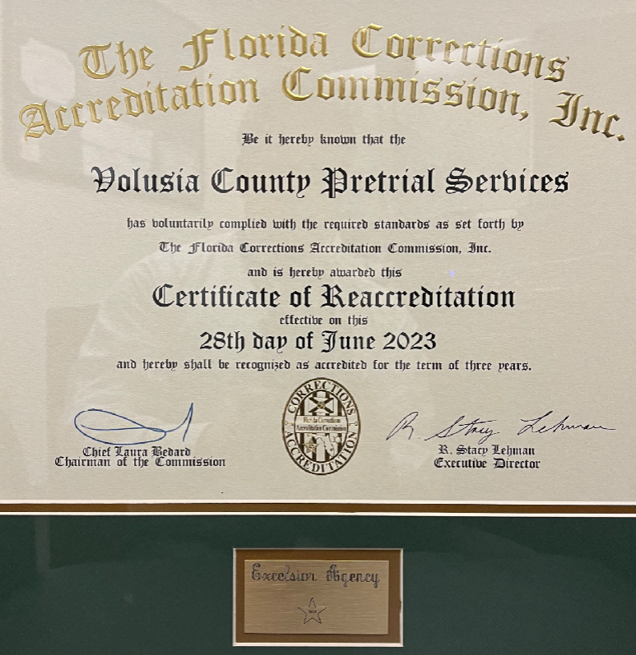

Each of the units within Volusia County Pretrial Services performs specialized functions, all vital to a successful and comprehensive program. As such, each unit has specific goals. Performance highlights of the Drug Screening Laboratories, Assessment, and Supervision units are as follows.

**Drug Screening Laboratories**

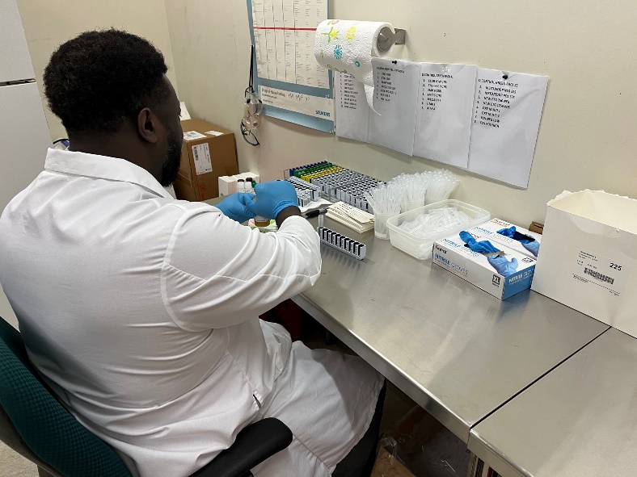The primary goal of the laboratories is to provide screening services in a professional manner to the court, court programs, and community-based programs, while applying best practices for collection and screening.

In accordance with best practices, the laboratories retain the services of an independent testing laboratory. This resource enables the laboratories to send urine specimens for additional testing to confirm screening results and test for additional substances of abuse.

The Volusia County laboratories will continue to place emphasis on meeting industry standards and provide educational training to community partners. The laboratories will continue to comply with State of Florida Department of Health regulations. In FY2024, the drug screening laboratories achieved a satisfactory inspection rating from the State of Florida Department of Health, the highest rating available, and increased the number of Certified Pretrial Services Professional lab staff.

**Drug Screening Laboratory Goals for 2025**

• Achieve a satisfactory inspection rating from the State of Florida Department of Health.

• Increase or maintain the number of lab staff who are Certified Pretrial Services Professionals through the National Association of Pretrial Services Agencies.

* Crosstrain lab staff in other pretrial departments.

**By the Numbers**

|  |  |  |
| --- | --- | --- |
| **FY2023** | **FY2024** | **Testing** |
| 171,305 | 152,413 | Individual screens run |
| 4,343 | 3,878 | Individual screens run with positive results |
| 18,949 | 15,990 | Specimens screened |
| 3,678 | 3,480 | Specimens with positive results |

**Assessment**

On a daily basis, including weekends and holidays, Pretrial Assessment diligently reviews defendant criminal histories, interviews defendants, and contacts alleged victims of domestic violence. This research is compiled to create a comprehensive report utilized by the First Appearance judge to make release decisions. During the 2024 fiscal year, 15,009 individuals attended First Appearance.

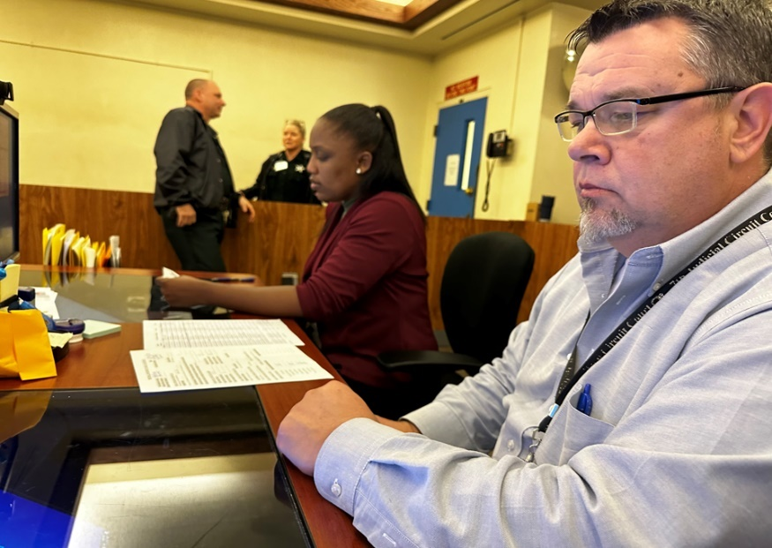On January 4, 2016, Volusia County Pretrial Services implemented the Public Safety Assessment (PSA), a nationally validated pretrial risk instrument created by Arnold Ventures. The PSA provides the judiciary with an unbiased and scientifically validated method of determining a defendant’s likelihood to commit new law violations and fail to appear for scheduled court events prior to case disposition. Additionally, the PSA is validated annually.

Additionally, the assessment unit coordinates with the jail regarding the release of individuals who are ordered to be monitored by Global Positioning Systems (GPS). This assures the GPS equipment is properly installed in a timely manner before a defendant is released from custody.

**Assessment Goals for 2025**

• Continue to explore ways to improve the remote First Appearance process.

* Maintain compliance with agency accreditation standards through the Florida Corrections Accreditation Commission.

• Increase or maintain the number of assessment staff who are Certified Pretrial Services Professionals through the National Association of Pretrial Services Agencies.

**By the Numbers**

|  |  |  |
| --- | --- | --- |
| **FY2023** | **FY2024** | **Testing** |
| 2,642 | 2,624 | Cases ordered to Pretrial Supervision at  First Appearance |
| 18% | 17% | Percent of cases released to Pretrial Supervision at First Appearance |
| 11,814 | 12,470 | Assessments completed |

**Supervision**

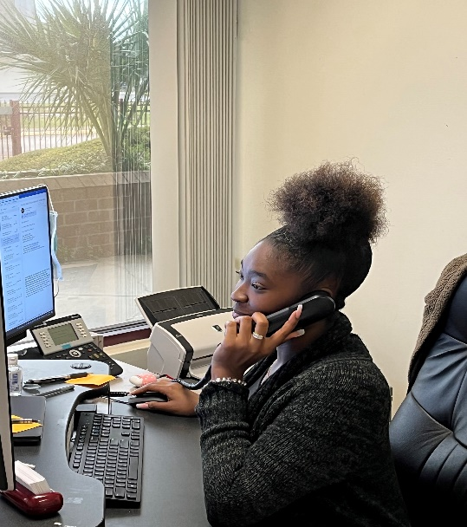Pretrial Supervision monitors defendants released into the community while awaiting disposition of their criminal cases. Supervision consists of monitoring compliance with court ordered conditions of release, ensuring appearances at scheduled court proceedings, and promoting a lawful lifestyle. The supervision unit monitored 3,601 cases in fiscal year 2024, resulting in a court appearance rate of 96%.

Periodically, judges request that the supervision unit attempt to locate a defendant who has failed to appear for a scheduled court date. During fiscal year 2024, 70 investigations were conducted, resulting in 40 defendants being successfully located and rescheduled for court. This avoids the costs associated with the service of a warrant.

All Pretrial Services units place an emphasis on continuing education. During this fiscal year, each pretrial employee completed a minimum of 40 hours of training, resulting in over 1,000 hours of training department wide. In fiscal year 2024, Pretrial Services maintained adherence to FCAC accreditation standards and increased the number of staff who achieved Certified Pretrial Services Professional status.

**Supervision Goals for FY2025**

* Maintain compliance with agency accreditation standards through the Florida Corrections Accreditation Commission.
* Increase or maintain the number of supervision staff who are Certified Pretrial Services Professionals through the National Association of Pretrial Services Agencies.
* Increase the number of FTA investigations.

**By the Numbers**

|  |  |  |  |  |
| --- | --- | --- | --- | --- |
| **FY2023** | | **FY2024** | | **Supervision** |
| 2,642 | | 2,624 | | New cases received at First Appearance |
| 300 | | 291 | | New cases received after First Appearance |
| 2,942 | | 2,887 | | Cases closed |
| 2,338 (80%) | | 2,315 (80%) | | Cases closed successfully |
| 2,817 (96%) | | 2,774 (96%) | | Cases closed without Failing to Appear |
| 2,062 (91%) | | 2,654 (92%) | | Cases closed without Failing to Comply |
| 2,135 (93%) | | 2,661 (92%) | | Cases closed without a New Arrest |
|  |  | |  | |

**Program Achievements and Projects**

* Four employees attended the 2024 National Association of Pretrial Services Conference.
* New employees were cross trained in various pretrial services disciplines.
* Staff participated (elected and appointed) in national and local pretrial related boards and committees.
* Staff participated in Operation Safe Surrender.
* Staff helped identify potential Veterans Court, DUI Court, and Drug Court candidates.
* The program received a proclamation from Volusia County acknowledging the agency’s success and commitment to excellence.
* A total of 13 employees have achieved or maintained certification, an increase from last year.
* All pretrial employees achieved or maintained FDLE Limited Access Certification.
* PSA enhancements continue to be implemented, increasing functionality.
* FTA investigations increased significantly (11 in FY2023 and 70 in FY2024) an increase of 536%.

**The Volusia County Pretrial Services statistical summary below captures fiscal year data from October 1 through September 30.**

**STATISTICAL SUMMARY & DATA FOR PRETRIAL SERVICES**

|  |  |  |  |  |  |  |
| --- | --- | --- | --- | --- | --- | --- |
| **6 YEAR COMPARISON** | **2019** | **2020** | **2021** | **2022** | **2023** | **2024** |
| **NUMBER OF DEFENDANTS AT FIRST APPEARANCE** | 18,351 | 15,586 | 15,669 | 15,465 | 14,540 | 15,009 |
| **NUMBER OF DEFENDANTS ORDERED TO PRETRIAL SERVICES** | 4,707 | 3,998 | 3,336 | 3,097 | 2,989 | 2,915 |
| **PRETRIAL SERVICES CASES CLOSED** | 4,733 | 3,838 | 3,603 | 3,374 | 2,942 | 2,887 |
| Unsuccessful | 1,377 | 997 | 829 | 694 | 604 | 572 |
| Successful | 3,356 | 2,841 | 2,774 | 2,680 | 2,338 | 2,315 |
| Appeared in court | 4,525 | 3,623 | 3,408 | 3,224 | 2,817 | 2,774 |
| Appearance Rate | 96% | 94% | 95% | 96% | 96% | 96% |
| No New Arrests | 4,366 | 3,409 | 3,252 | 3,142 | 2,135 | 2,661 |
| No New Arrests Rate | 92% | 89% | 90% | 93% | 93% | 92% |
| Complied with Program | 3,356 | 3,485 | 3,346 | 3,062 | 2,062 | 2,654 |
| Compliance Rate | 83% | 91% | 93% | 91% | 91% | 92% |